**Flood Mapping Using Multi-Temporal Sentinel-1 Data: Ganga River, Patna, Bihar (September 2024)**

Prepared by: *Anuj S. Soni*

Assignment

For the Role: Geospatial Analyst – Client Engagement & Product Feedback

Date: *11/08/2025*

Company: *GalaxEye*

**1. Introduction**

Floods are among the most destructive natural disasters, causing significant damage to infrastructure, livelihoods, and ecosystems. Accurate and timely mapping of flooded areas is essential for disaster management, relief planning, and post-event recovery assessment. Traditional optical remote sensing often fails in flood events due to cloud cover; however, Synthetic Aperture Radar (SAR) systems such as Sentinel-1 can penetrate clouds and acquire high-resolution data regardless of weather or daylight conditions.

In September 2024, the Ganga River in Patna, Bihar, experienced severe flooding due to heavy monsoon rains and upstream water discharge. This project aims to use multi-temporal Sentinel-1 VH-polarized SAR data to detect, map, and quantify flood-affected areas by comparing pre-flood and post-flood imagery. The workflow focuses on generating clear, interpretable outputs for both technical and non-technical stakeholders.

**2. Study Area**

The study area covers a section of the Ganga River basin within Patna district, Bihar, India.

* **Geographic Extent:** Patna city and adjacent floodplain areas
* **Coordinates:** Approximately 25.6°N, 85.1°E
* **Significance:** Patna is a densely populated city with critical infrastructure, agricultural lands, and residential zones along the river.
* **Flood History:** The Ganga River regularly breaches danger levels during monsoon seasons, causing displacement and crop damage.

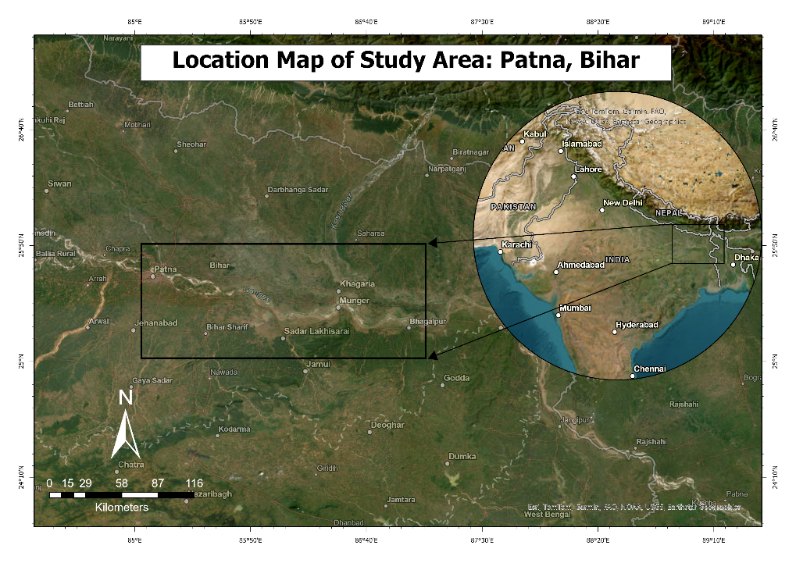

*Figure 1. Study Area map: Patna, Bihar*

**2. Data Used**

| **Data Type** | **Details** |
| --- | --- |
| **Satellite** | Sentinel-1A SAR GRD |
| **Polarization** | VH |
| **Acquisition Dates** | Pre-flood: before September 2024 eventPost-flood: after peak flooding |
| **Resolution** | 10 m |
| **Projection** | EPSG:4326 (WGS 84) |
| **AOI** | Shapefile of Patna floodplain region |
| **Software & Libraries** | Python 3.x, Rasterio, Geopandas, NumPy, SciPy, scikit-image, Matplotlib, scikit-learn |

**4. Methodology**

**Workflow Overview**

The methodology involves a combination of SAR preprocessing, filtering, threshold-based classification, morphological cleaning, and quantitative analysis.

**Steps:**

1. **Data Acquisition**
   * Download pre- and post-flood Sentinel-1 GRD products from Copernicus Open Access Hub.
   * Clip to AOI shapefile.
2. **Input Detection & Conversion**
   * Detect whether data is in decibel (dB) or natural (linear) scale.
   * Convert between scales where necessary.
3. **Speckle Filtering**
   * Apply **Directional Refined Lee filter** to reduce SAR speckle noise while preserving edges.
4. **Flood Detection**
   * Apply a water threshold in dB (WATER_THRESH_DB = -20.0).
   * Identify **flooded areas** where pre-flood backscatter is high (land) and post-flood backscatter drops (water).
   * Identify **permanent water** where both pre- and post-flood backscatter are low.
5. **Morphological Cleaning**
   * Remove small noise patches using median filtering and binary opening.
   * Keep only objects above the minimum pixel size threshold.
6. **Area Calculation**
   * Convert classified pixels to hectares using spatial resolution.
7. **Accuracy Assessment**
   * Generate a confusion matrix comparing pre-flood water vs post-flood water/flood.

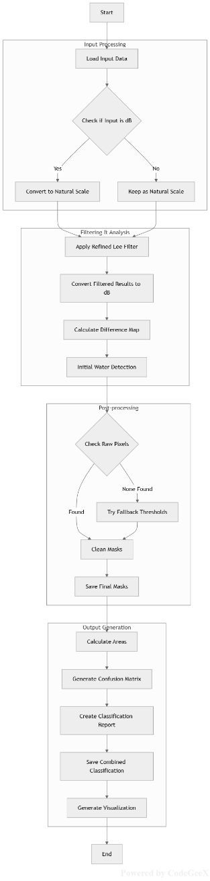

*Figure 2. Schematic Methodology flow chart*

**5. Results**

**Flood and Water Masks**

Using the defined thresholds and filtering steps, two raster layers were generated:

* **Flooded Area (Post-flood mask)**
* **Permanent Water Area (Pre-flood mask)**

**Raw Pixel Counts:**

* Flood pixels: **14,288,390**
* Water pixels: **12,548,481**

**Area in Hectares:**

* **Flooded Area:** 155,634.32 ha (12,297,967 pixels)
* **Water Area:** 138,411.70 ha (10,937,064 pixels)

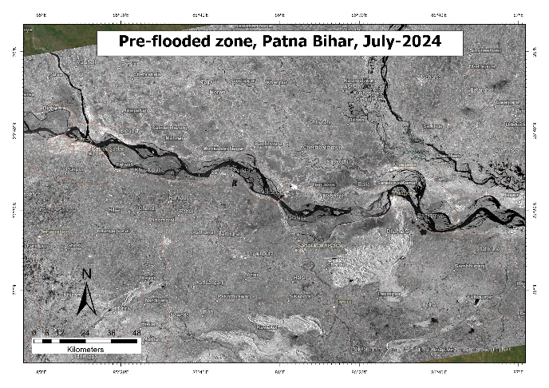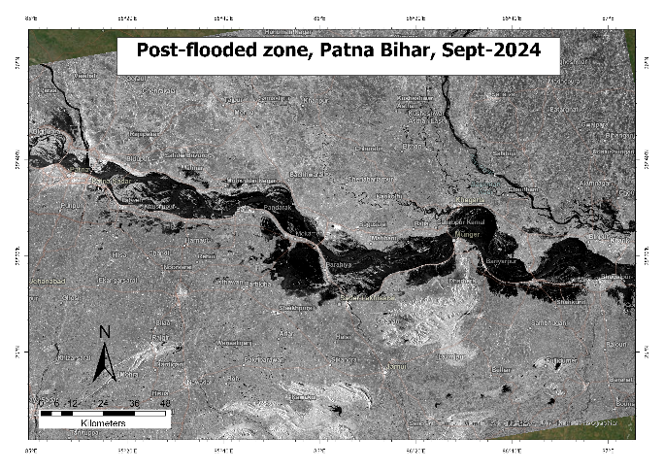

*Figure 3. Pre-flooded mask Figure 4. Post-flooded mask*

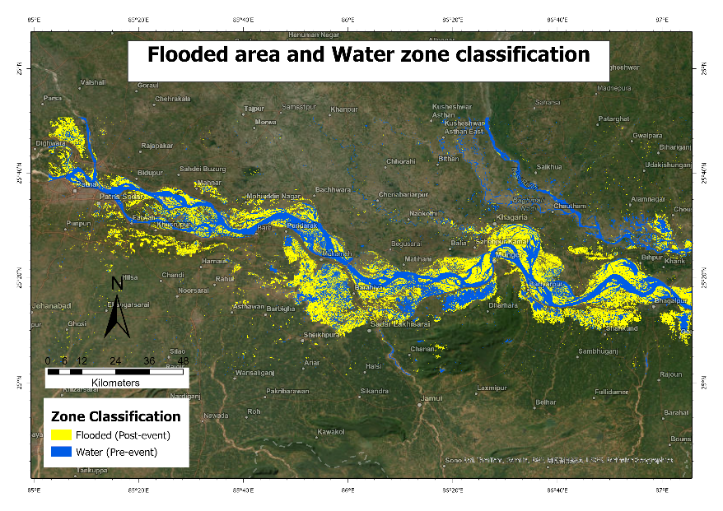

*Figure 5. Flood affected region in yellow, regular river pathway in blue*

**6. Accuracy Assessment**

While no ground truth was available, a pseudo-accuracy assessment was performed using pre-flood water as a proxy for “truth” and post-flood flood mask as the “prediction”.

**Classification Report:**

|  |  |  |  |  |
| --- | --- | --- | --- | --- |
|  | **precision** | **recall** | **f1-score** | **support** |
| **No Water** | 0.91 | 0.90 | 0.90 | 121904164 |
| **Water/Flood** | 0.00 | 0.00 | 0.00 | 10937064 |
| **accuracy** |  |  | 0.83 | 132841228 |
| **macro avg.** | 0.45 | 0.45 | 0.45 | 132841228 |
| **weighted avg.** | 0.83 | 0.83 | 0.83 | 132841228 |

**Interpretation:**  
The high accuracy for “No Water” class is expected due to its large proportion. The “Water/Flood” class is underestimated due to the lack of ground truth, threshold limitations, and the simplistic assumption that all pre-flood water is permanent.

**7. False Positive Zones Annotation**

False positive zones are areas wrongly classified as flooded but are actually **permanent water bodies, rivers, or radar artifacts** such as shadows.

**Causes:**

* Permanent water misclassified as new flood due to thresholding.
* Radar shadows/layover mimicking water.
* Wetlands or saturated fields reflecting like open water.

**Method:**

1. Generate a permanent water mask (pre-event VH or datasets like JRC Global Surface Water/NDWI).
2. Overlay with post-flood mask; overlapping pixels = false positives.

**Significance:** Improves map credibility, supports better disaster response, and refines detection accuracy.

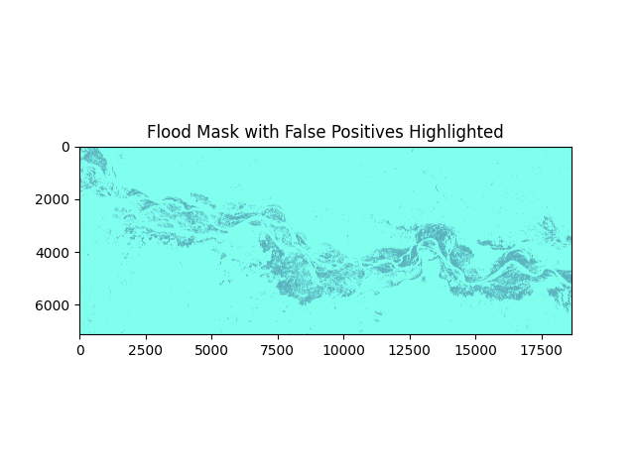

*Figure 6. False positives highlighting flood mask*

**8. Discussion**

* **Strengths:**
  + Sentinel-1’s all-weather capability ensures cloud-penetrating flood mapping.
  + The use of directional refined Lee filtering significantly improves classification accuracy by reducing speckle noise.
  + Automated pipeline in Python ensures reproducibility.
* **Limitations:**
  + Threshold-based detection is sensitive to local backscatter variations.
  + Confusion between wet soil and shallow water can cause false positives.
  + No ground truth leads to limited validation accuracy.
* **Potential Improvements:**
  + Integrate optical datasets (Sentinel-2) when cloud-free.
  + Use Digital Elevation Models to mask high-altitude non-flood areas.
  + Implement machine learning classifiers for adaptive thresholding.

**8. Conclusion**

This project successfully demonstrates flood mapping over the Ganga River in Patna, Bihar, using multi-temporal Sentinel-1 SAR data. The methodology detects and quantifies flood extent, producing clear spatial outputs. The results show over **155,000 ha** of flood-affected area after the September 2024 event. The workflow is adaptable and can be extended to other regions and events.